**HTML Tutorial: HTML Entities | Web Development Tutorials #11**

**HTML Tutorial- HTML Entities**

This tutorial is about different [Entities](https://developer.mozilla.org/en-US/docs/Glossary/Entity) used in the HTML. An entity is a piece of text (“string”) that begins with an ‘*&’*and ends with a ‘;’. These are frequently used to display reserved characters, and invisible characters. As usual, let us begin the tutorial by making a new HTML file as *tut11.html*and add an instant boilerplate to get the basic template of HTML. Give the title as *HTML Entities*in the <title> tag.

Try to understand with the below example. If we write the code as

<div class= “container”>

<p>This is a Paragraph</p>

</div>

<div class= “container”>

<p>This is another Paragraph</p>

</div>

Copy

If we add some spaces in between these texts then what will you expect?

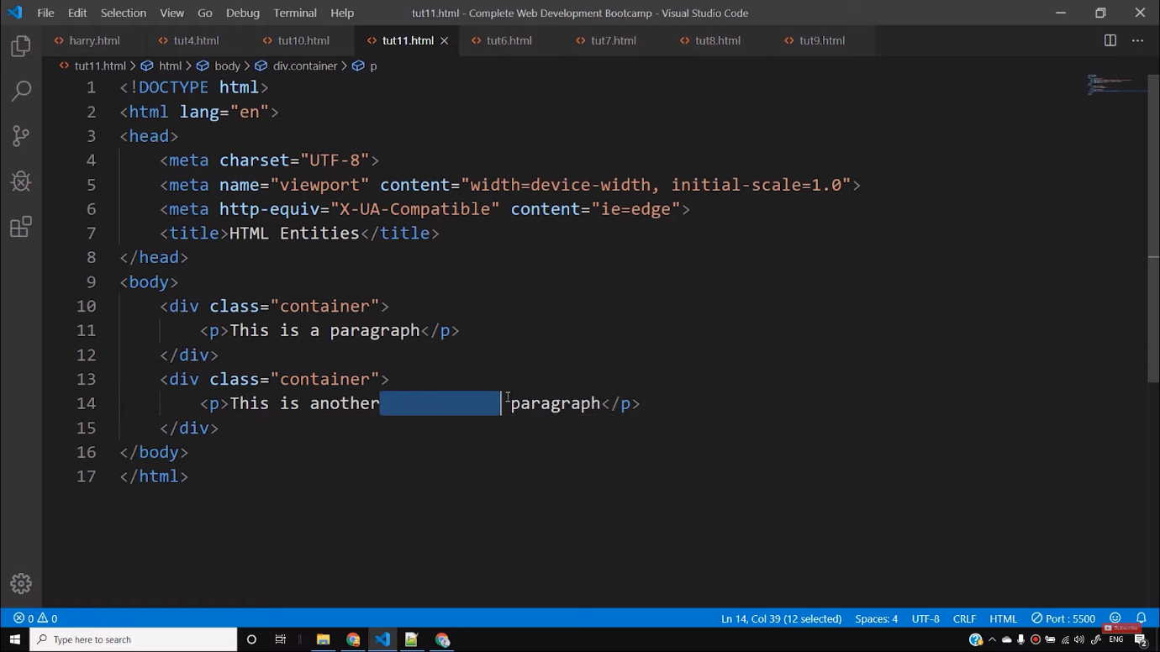

You will normally say that all the extra spaces will reflect back on the webpage. But it is not so. Because HTML treats all the extra spaces as a single space only and automatically removes all of them. Therefore, if you want to use extra spaces or any special characters, then you have to use HTML entities. To get extra space we can use ***&nbsp***(non-breaking space)after that particular text. For example-

<div class= “container”>

<p>This is another &nbsp Paragraph</p>

</div>

Copy

By writing this way, we can create 1 extra space after the word *another.*By adding five *&nbsp,*we can get 5 extra spaces. However, I do not recommend using this method because it looks unprofessional. We will learn to create extra spaces in CSS with the help of margin, padding, or selectors that looks more professional.

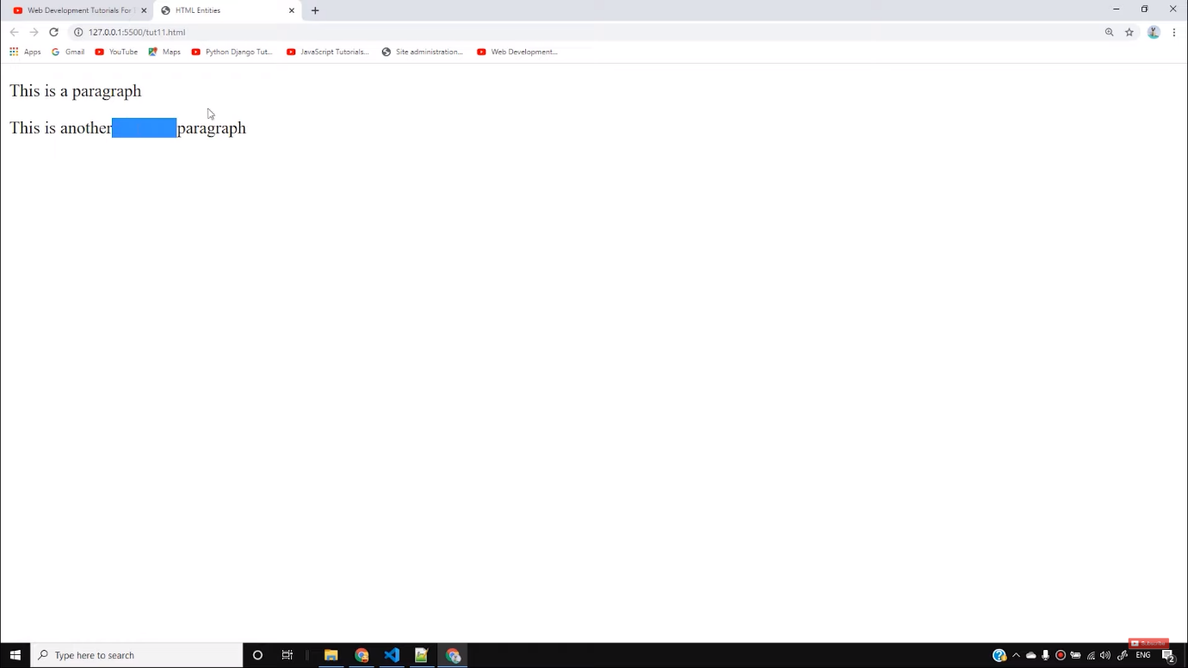

Entities are also used to write some special characters that you cannot write from keyboards and also those words that are reserved in HTML. For example, if we want ***<p>*** to appear in the result, then it is not possible without the help of entities.

<div class= “container”>

<p>This is another Paragraph<p></p>

</div>

Copy

By writing the above code, we will see that we cannot obtain the ***<p>***in our result. Therefore, the solution for this is we can take the help of HTML entities. We have to write in this format-

<div class= “container”>

<p>This is another Paragraph &lt;p&gt; </p>

</div>

Copy

There is a list of different reserved characters and hundreds of special characters that you cannot write without entities. There is no need to learn all those entities available. You are always free to take the help of various references available.

So, this is all for this tutorial and I hope you have got the basic knowledge about HTML entities. If you still have any queries, feel free to ask.

**Code as described/written in the video**

<!DOCTYPE html>

<html lang="en">

<head>

<meta charset="UTF-8">

<meta name="viewport" content="width=device-width, initial-scale=1.0">

<meta http-equiv="X-UA-Compatible" content="ie=edge">

<title>HTML Entities</title>

</head>

<body>

<div class="container">

<p>This is a paragraph</p>

</div>

<div class="container">

<p>This is another paragraph with two spaces</p>

<p>Paragraph is written like this <p> </p>

<p>Pound is written like this £ </p>

<p>Copyright is written like this © </p>

<p>Another character is ⇛ </p>

<p>Another character is ¼ </p>

<p>Empty character is written like this ​ </p>

</div>

</body>

</html>

Character entities are used to display reserved characters in HTML.

A character entity looks like this:

&*entity_name*;

OR

&#*entity_number*;

To display a less than sign (<) we must write: **&lt;** or **&#60;**

## **Non-breaking Space**

A commonly used entity in HTML is the non-breaking space: **&nbsp;**

A non-breaking space is a space that will not break into a new line.

If you write 10 spaces in your text, the browser will remove 9 of them. To add real spaces to your text, you can use the **&nbsp;** character entity.

**Tip:** The non-breaking hyphen ([&#8209;](https://www.w3schools.com/charsets/ref_utf_punctuation.asp)) is used to define a hyphen character (‑) that does not break into a new line.

## **Some Useful HTML Character Entities**

|  |  |  |  |  |
| --- | --- | --- | --- | --- |
| **Result** | **Description** | **Entity Name** | **Entity Number** | **Try it** |
|  | non-breaking space | &nbsp; | &#160; | [Try it »](https://www.w3schools.com/html/tryit.asp?filename=tryhtml_ent_nbsp) |
| < | less than | &lt; | &#60; | [Try it »](https://www.w3schools.com/html/tryit.asp?filename=tryhtml_ent_lt) |
| > | greater than | &gt; | &#62; | [Try it »](https://www.w3schools.com/html/tryit.asp?filename=tryhtml_ent_gt) |
| & | ampersand | &amp; | &#38; | [Try it »](https://www.w3schools.com/html/tryit.asp?filename=tryhtml_ent_amp) |
| " | double quotation mark | &quot; | &#34; | [Try it »](https://www.w3schools.com/html/tryit.asp?filename=tryhtml_ent_quot) |
| ' | single quotation mark (apostrophe) | &apos; | &#39; | [Try it »](https://www.w3schools.com/html/tryit.asp?filename=tryhtml_ent_apos) |
| ¢ | cent | &cent; | &#162; | [Try it »](https://www.w3schools.com/html/tryit.asp?filename=tryhtml_ent_cent) |
| £ | pound | &pound; | &#163; | [Try it »](https://www.w3schools.com/html/tryit.asp?filename=tryhtml_ent_pound) |
| ¥ | yen | &yen; | &#165; | [Try it »](https://www.w3schools.com/html/tryit.asp?filename=tryhtml_ent_yen) |
| € | euro | &euro; | &#8364; | [Try it »](https://www.w3schools.com/html/tryit.asp?filename=tryhtml_ent_euro) |
| © | copyright | &copy; | &#169; | [Try it »](https://www.w3schools.com/html/tryit.asp?filename=tryhtml_ent_copy) |
| ® | registered trademark | &reg; | &#174; | [Try it »](https://www.w3schools.com/html/tryit.asp?filename=tryhtml_ent_reg) |

**Note:** Entity names are case sensitive.

## **Combining Diacritical Marks**

A diacritical mark is a "glyph" added to a letter.

Some diacritical marks, like grave (  ̀) and acute (  ́) are called accents.

Diacritical marks can appear both above and below a letter, inside a letter, and between two letters.

Diacritical marks can be used in combination with alphanumeric characters to produce a character that is not present in the character set (encoding) used in the page.

Here are some examples:

|  |  |  |  |  |
| --- | --- | --- | --- | --- |
| **Mark** | **Character** | **Construct** | **Result** | **Try it** |
| ̀ | a | a&#768; | à | [Try it »](https://www.w3schools.com/html/tryit.asp?filename=tryhtml_ent_a768) |
| ́ | a | a&#769; | á | [Try it »](https://www.w3schools.com/html/tryit.asp?filename=tryhtml_ent_a769) |
| ̂ | a | a&#770; | â | [Try it »](https://www.w3schools.com/html/tryit.asp?filename=tryhtml_ent_a770) |
| ̃ | a | a&#771; | ã | [Try it »](https://www.w3schools.com/html/tryit.asp?filename=tryhtml_ent_a771) |
| ̀ | O | O&#768; | Ò | [Try it »](https://www.w3schools.com/html/tryit.asp?filename=tryhtml_ent_o768) |
| ́ | O | O&#769; | Ó | [Try it »](https://www.w3schools.com/html/tryit.asp?filename=tryhtml_ent_o769) |
| ̂ | O | O&#770; | Ô | [Try it »](https://www.w3schools.com/html/tryit.asp?filename=tryhtml_ent_o770) |
| ̃ | O | O&#771; | Õ |  |